ETHICAL SOFTWARE Community
Mindmap Software Guide

Table of contents

Minder 1
Minder Installation Guide (Fedora Linux) 2
Building your First Mind Map with Minder 8
Draw.io 15
Draw.io Installation Guide (Fedora Linux) 16

Minder
Minder is a Mind-mapping application for Elementary OS.
Free and open source.

Minder Installation Guide (Fedora Linux)
Here is the Simple Tutorial that helps you install Minder on Fedora Linux. Let’s get started.

Step 1. First, on your Fedora, move your mouse to the top-left corner of your screen.
You should see the following screen:
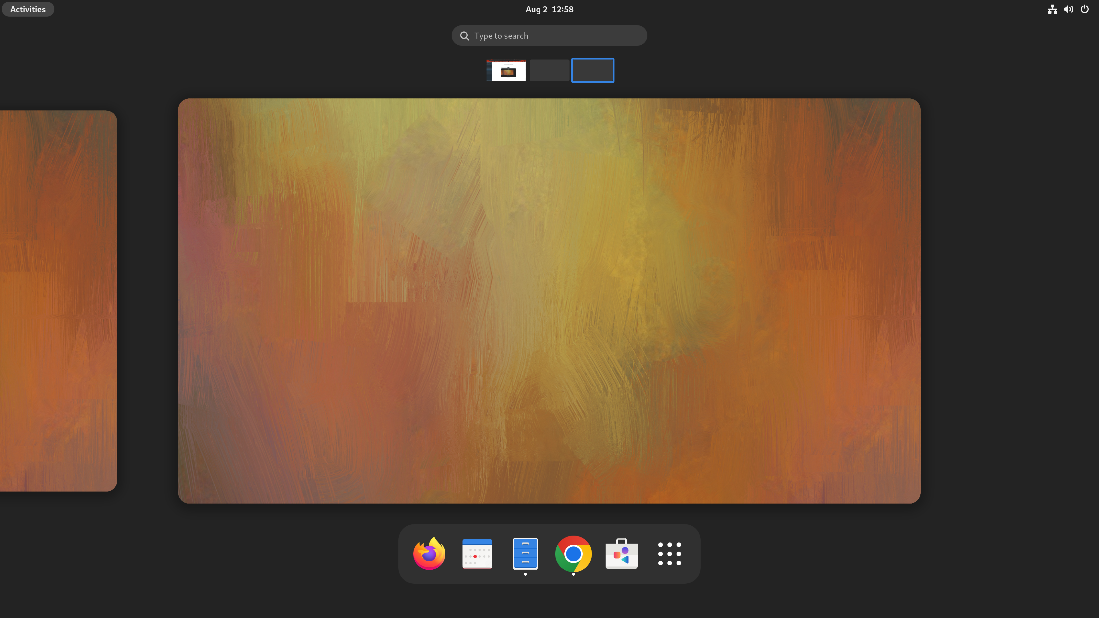

Step 2. Left Click “Type to search”.
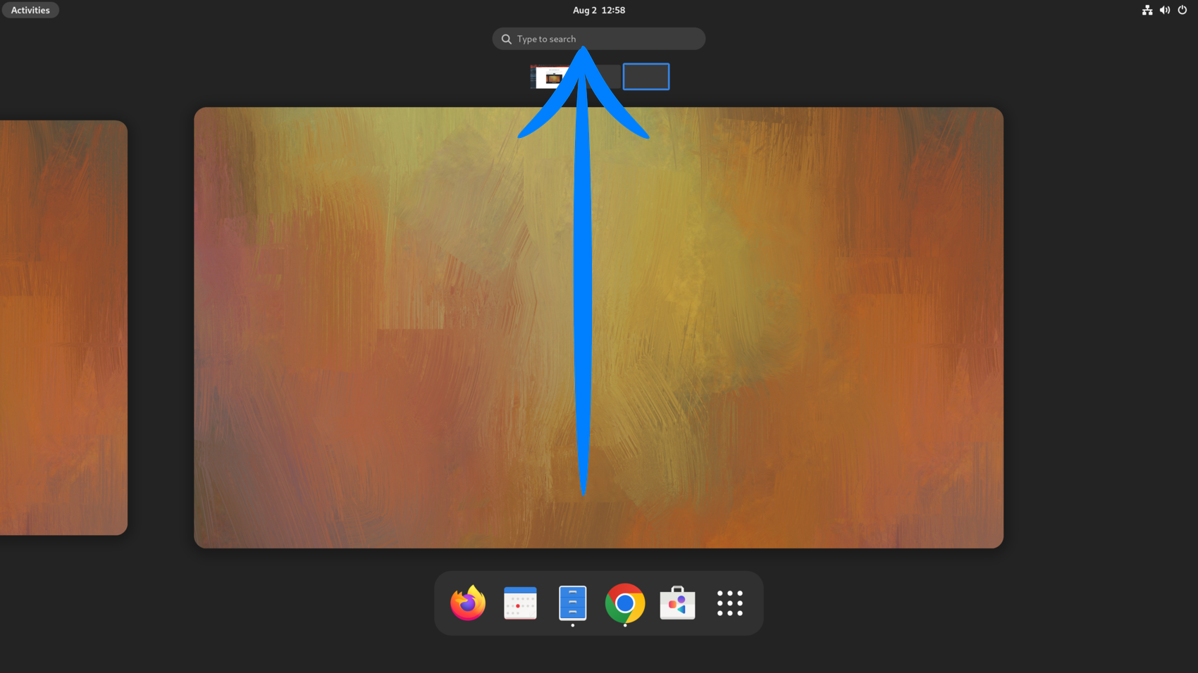

Step 3. Enter the word “Terminal”.
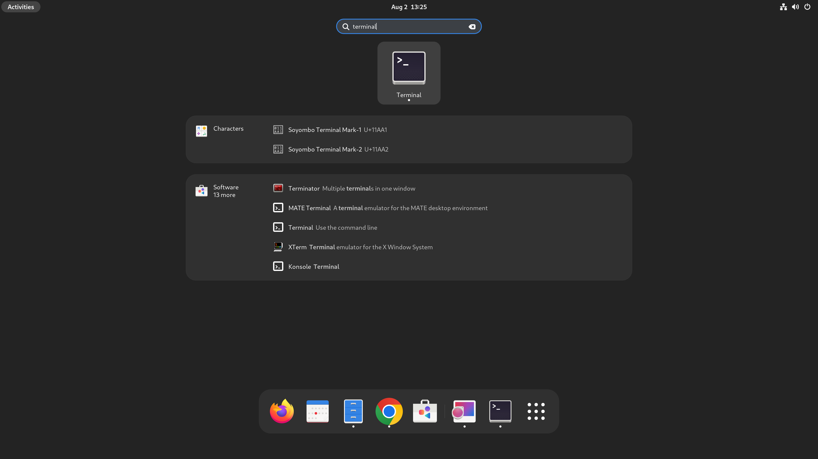

Step 4. After Left Clicking on the Terminal Icon. You should see the following terminal pop out.
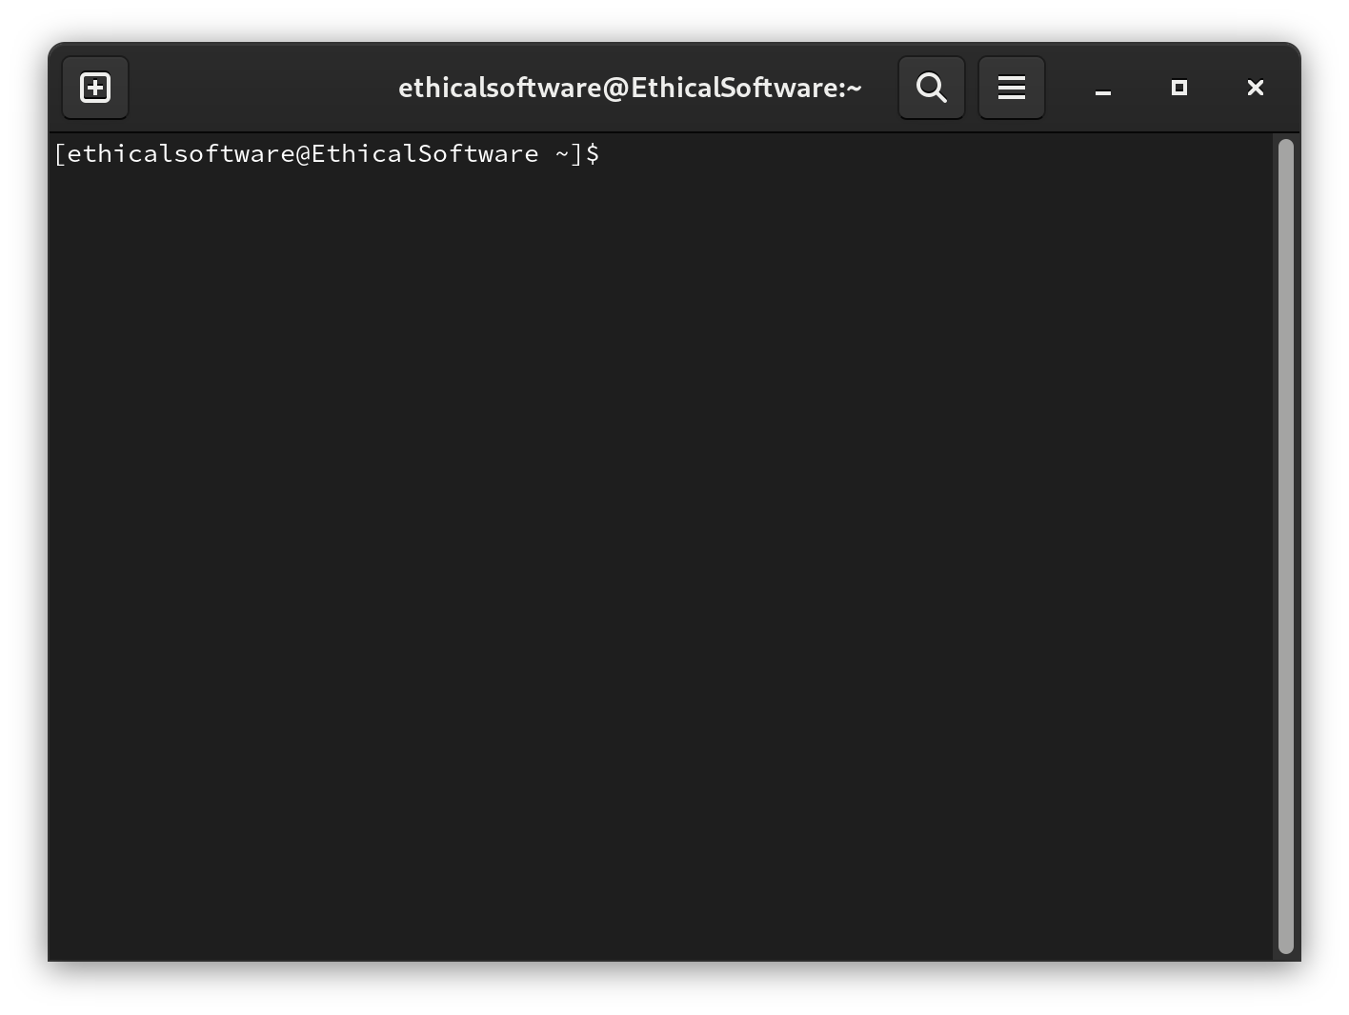
Step 5. Enter the above command in the terminal:
sudo dnf install minder
Then enter your user password into the terminal.
Make sure you have the same output as follows.
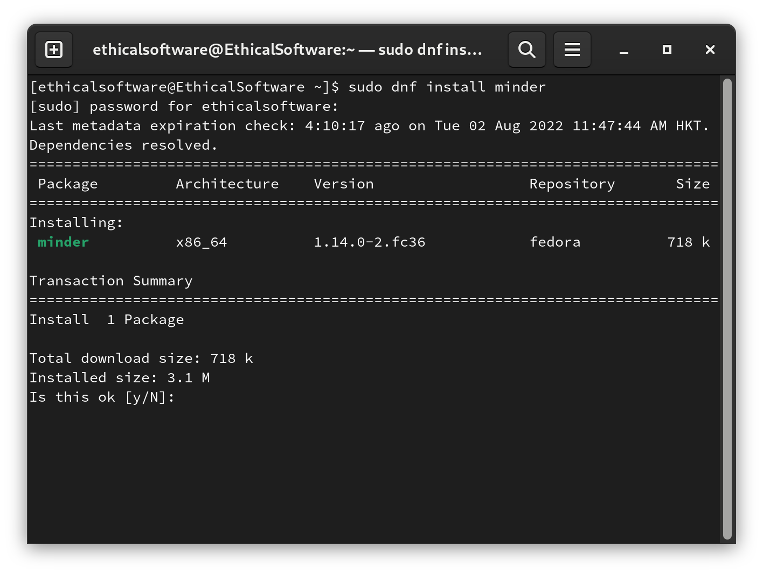
Step 6. Enter the letter: y, and you should see the following output.
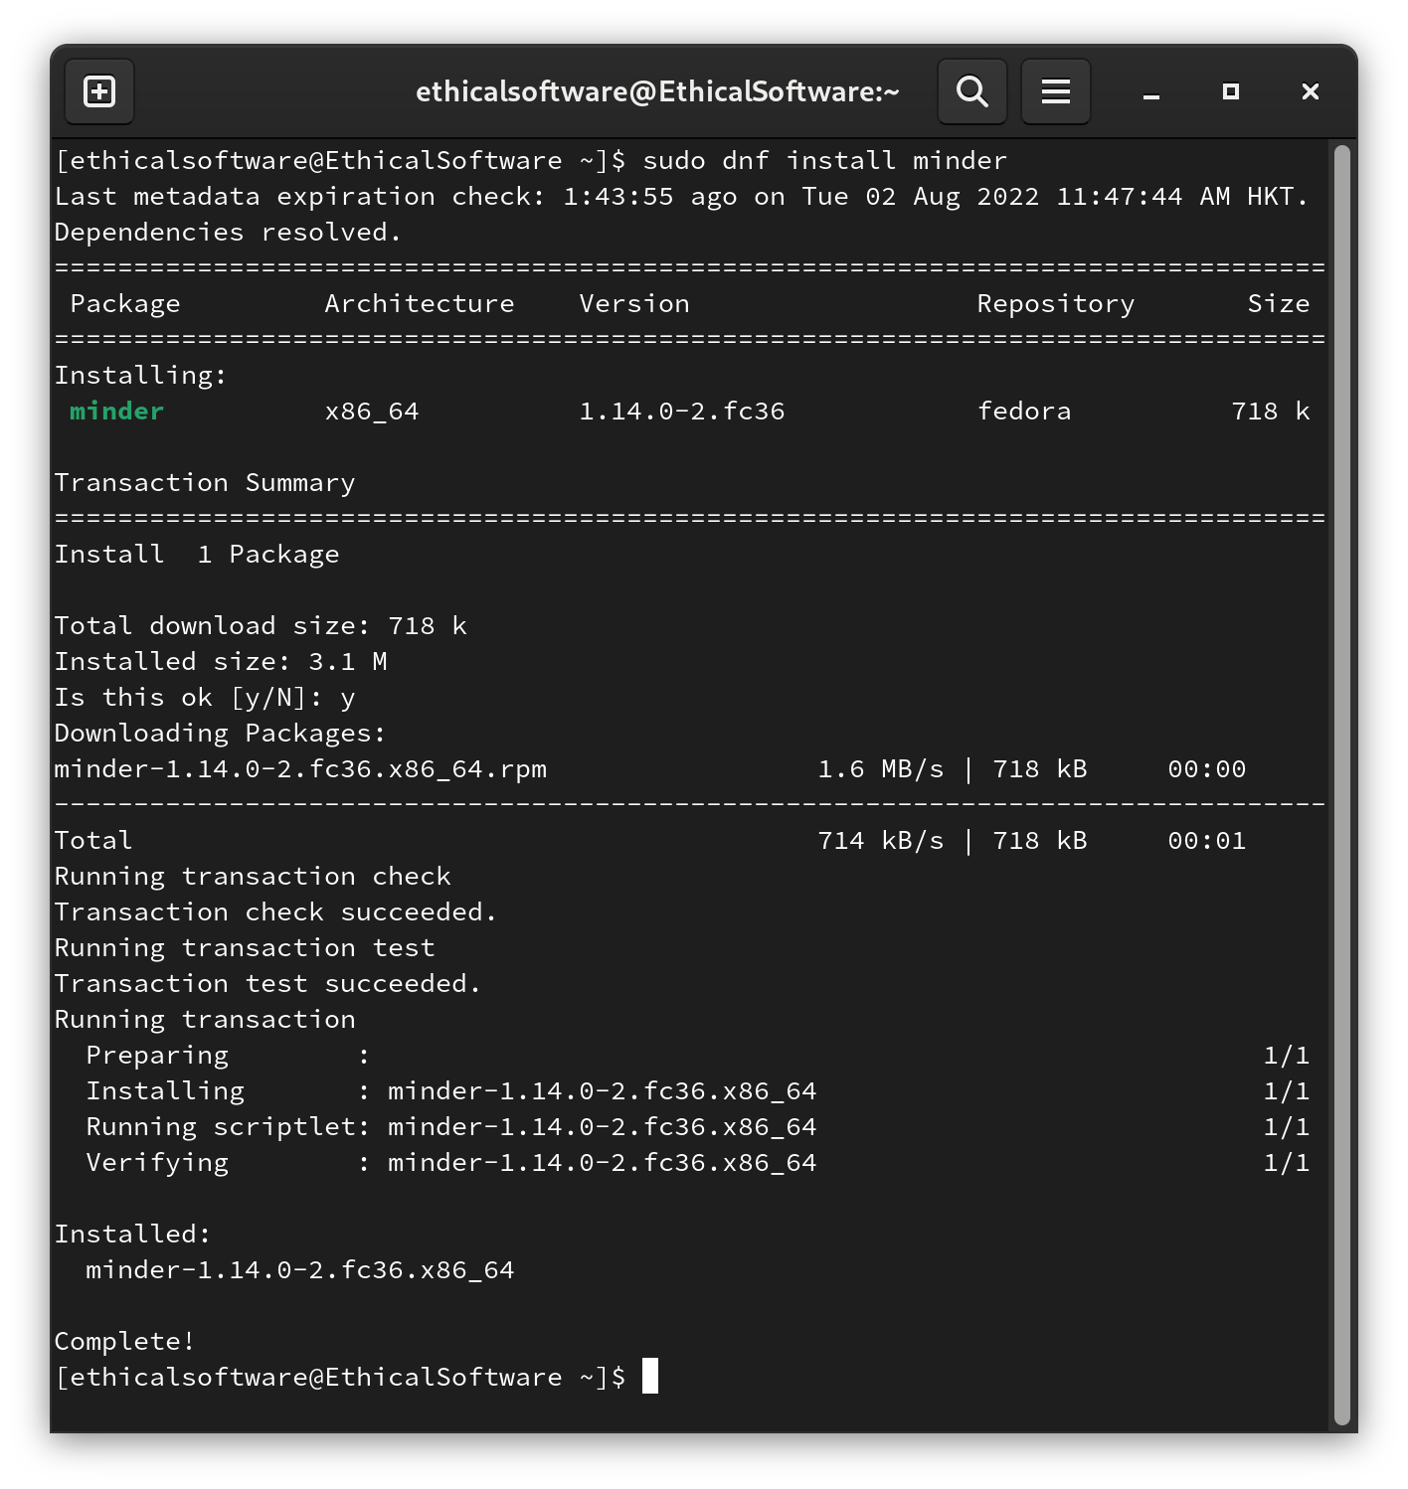

Step 7: Repeat Step 1 and enter the word “minder”.
You should see the Minder Icon. Left Click on the Icon and create your mind map with Minder!
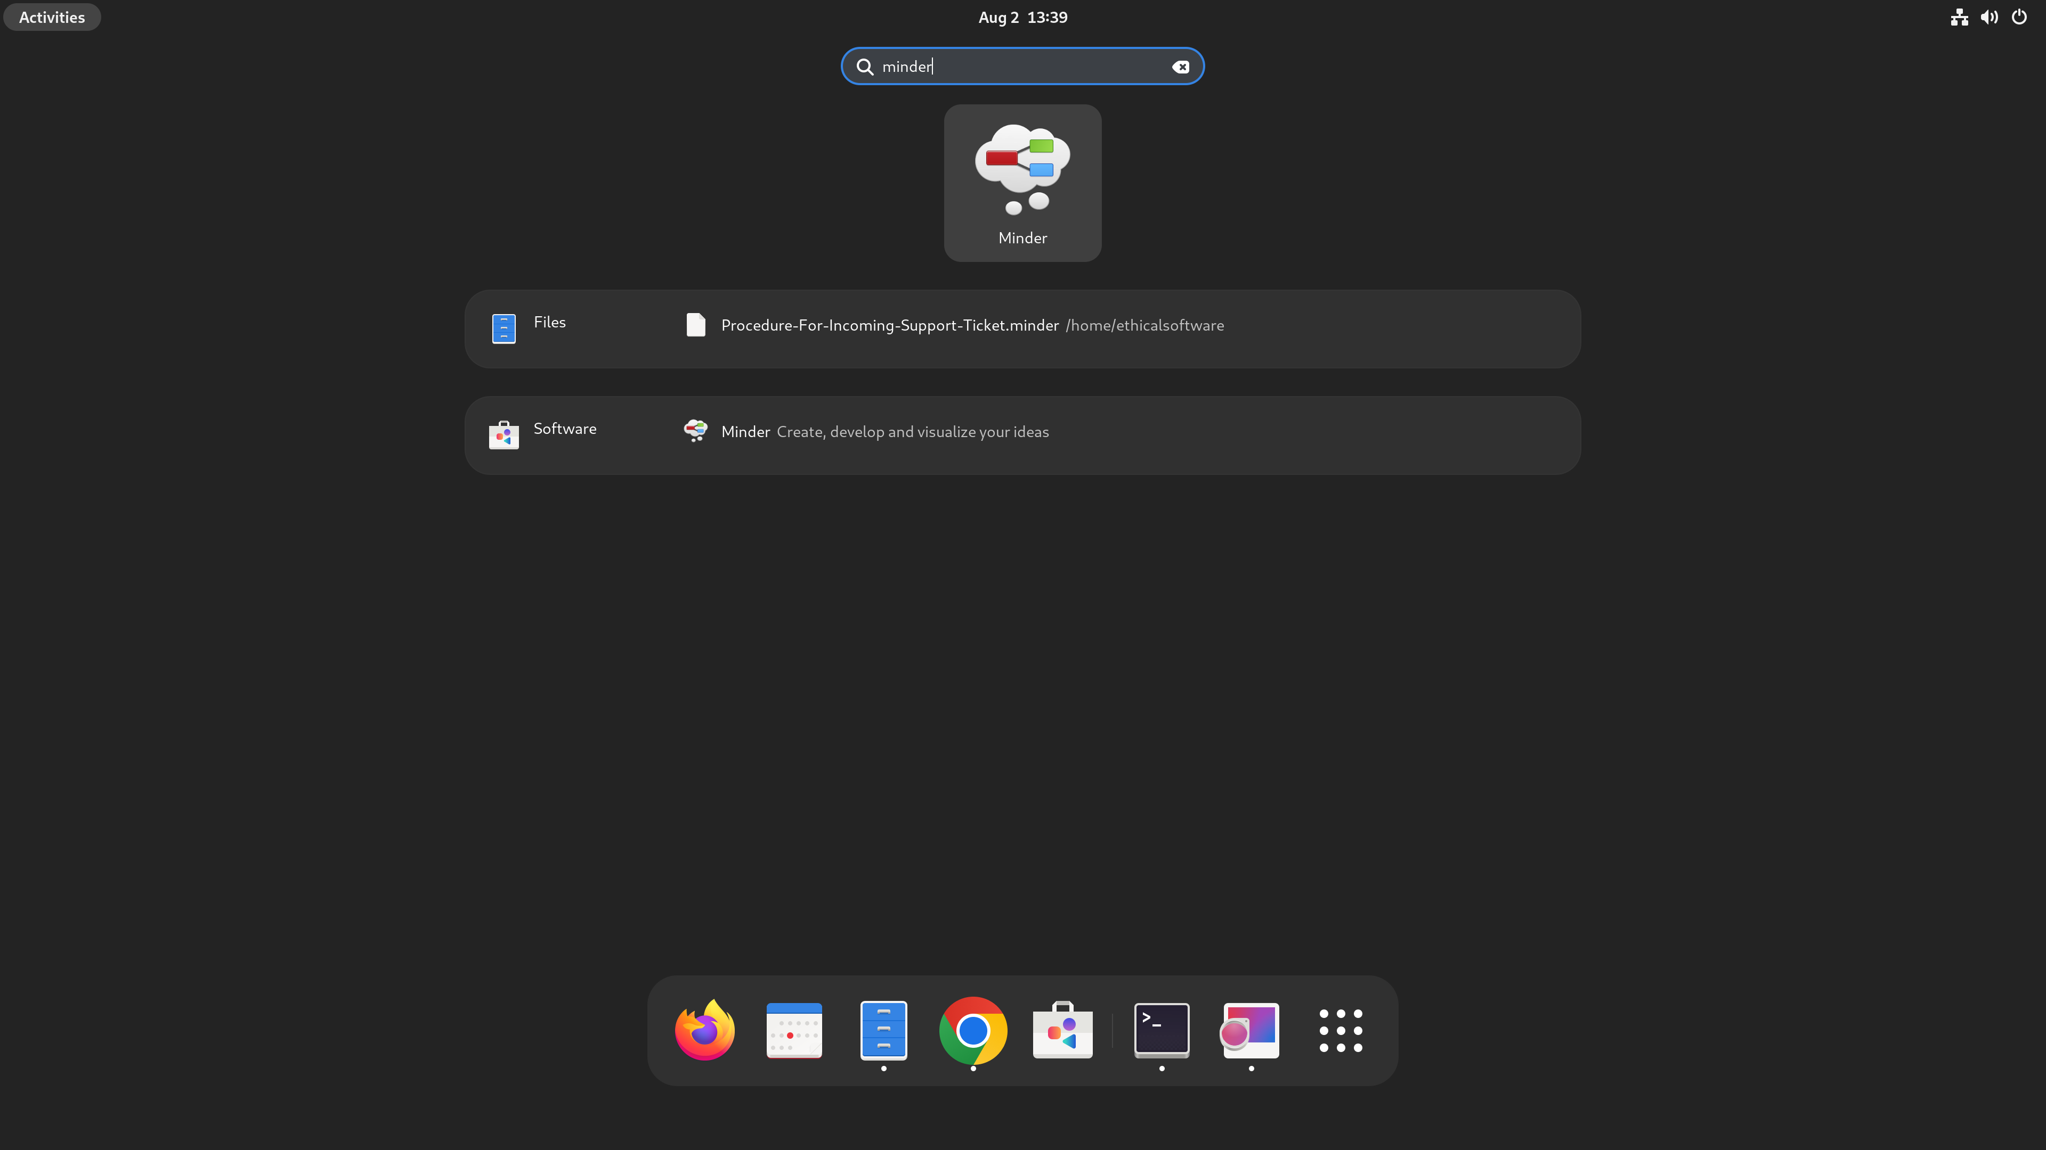
E.N.D

Building your First Mind Map with Minder
Basic Knowledge: Note is considered the fundamental component of Minder.
Each “Root note” will be associated with multiple “Child Notes”.
Correlated as “Main Idea” and “Supporting Idea”.

Here is the Tutorial that helps in building your first Minder mind map. Let’s get started.

Step 1. First, open your Minder Application, and move your mouse to the top-left corner of your screen. You should see the following screen:

Step 2. Left Click “Type to search”.
Step 3. Enter the word “minder”.
Step 4. After Left Clicking on the Minder Icon. You should see the Minder pop out with a Pre-Defined Root Note.
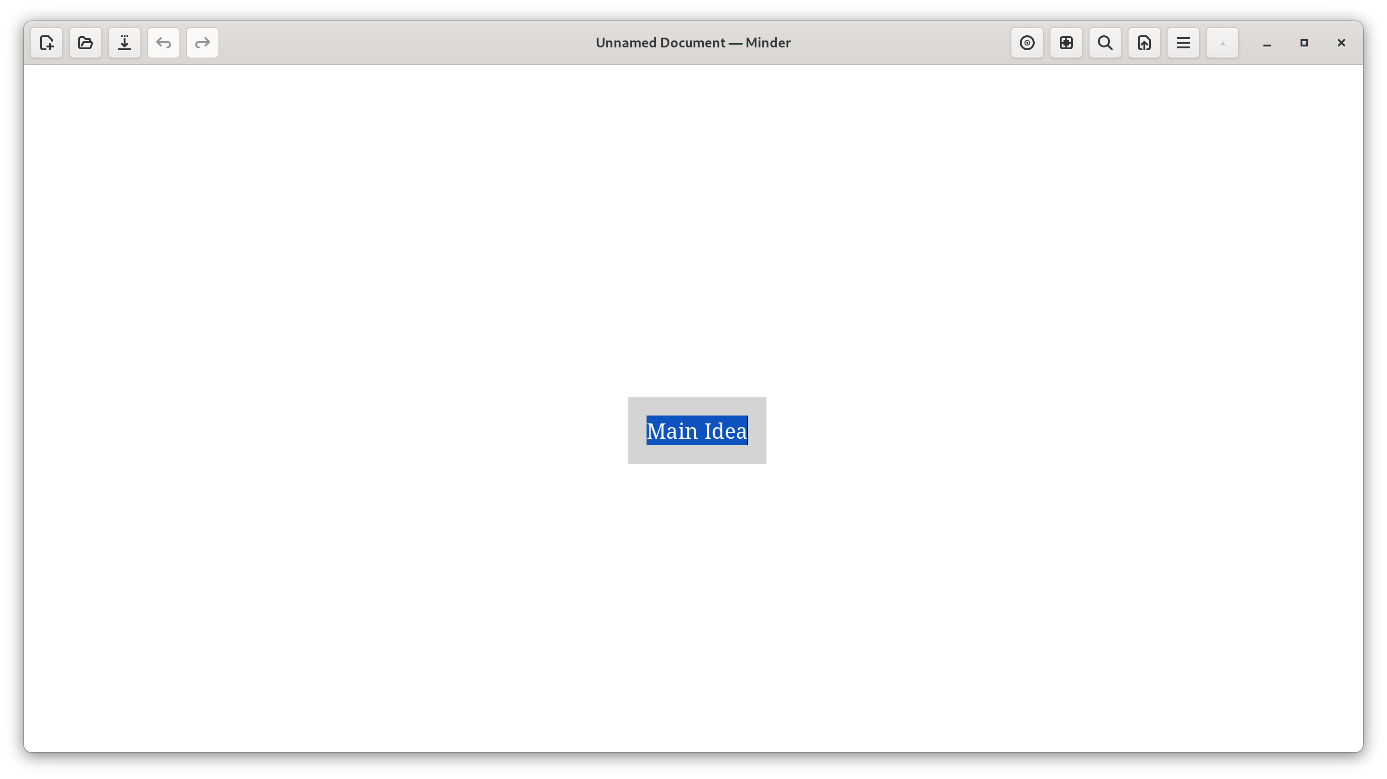
Step 5. Enter your “Main Idea“ into the Root Note.
We will take “Game Development” as our “Main Idea”.
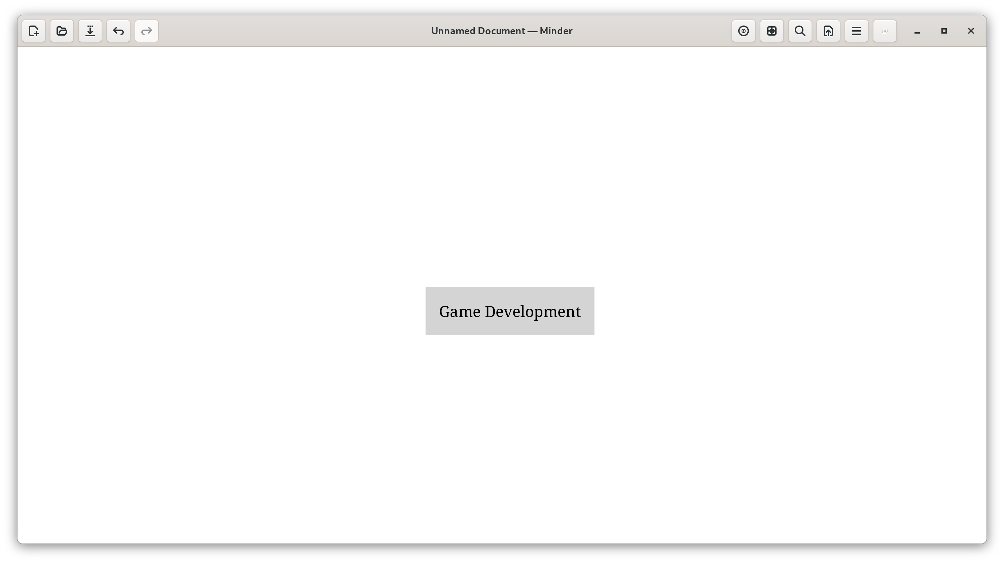
Step 6. In order to create a Child Node to your Root Node:
- Left Click on the Root Note (“The first mind map idea”)
- Press the “Tab” key on your keyboard, and the Child Node will pop up.
- Enter the “Supporting Idea” for your “Main Idea”.
- In our case, we will enter the “Animation and Graphics” as the Child Note.
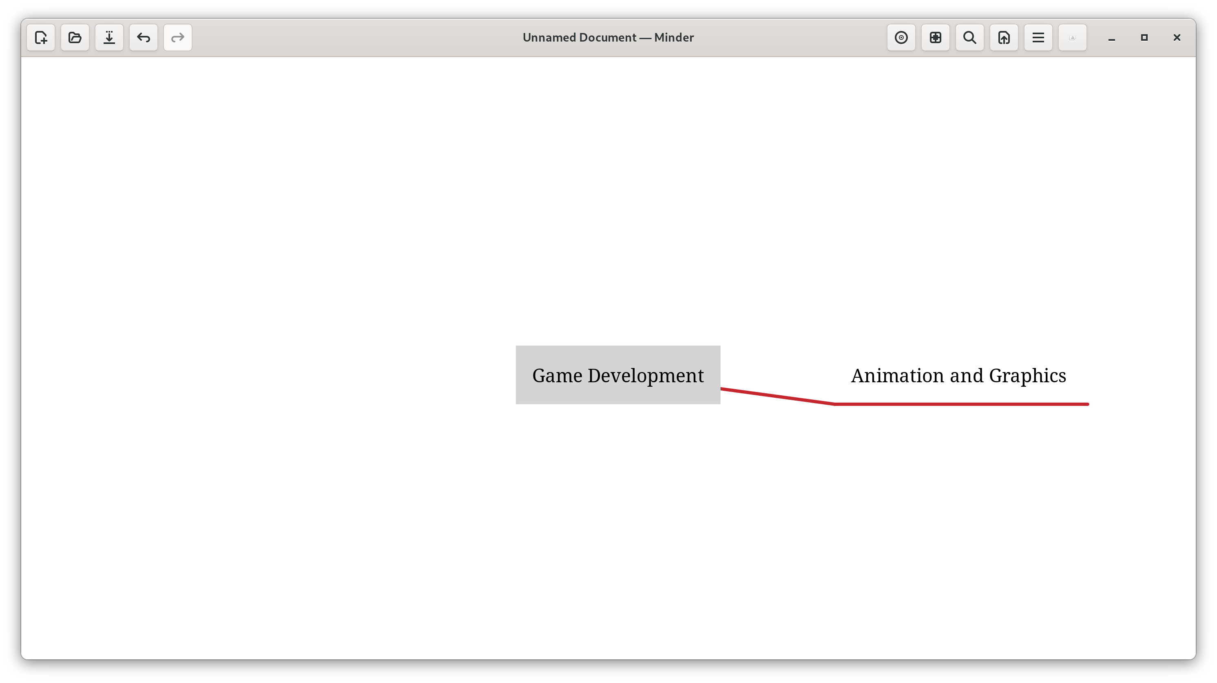
Step 7. In addition, we could create multiple Child Notes for a single Root Note.
The step is just to repeat Step 6, and we could quickly insert another Child Note.
In our case, we will be creating a Child Note named “Music Production”.
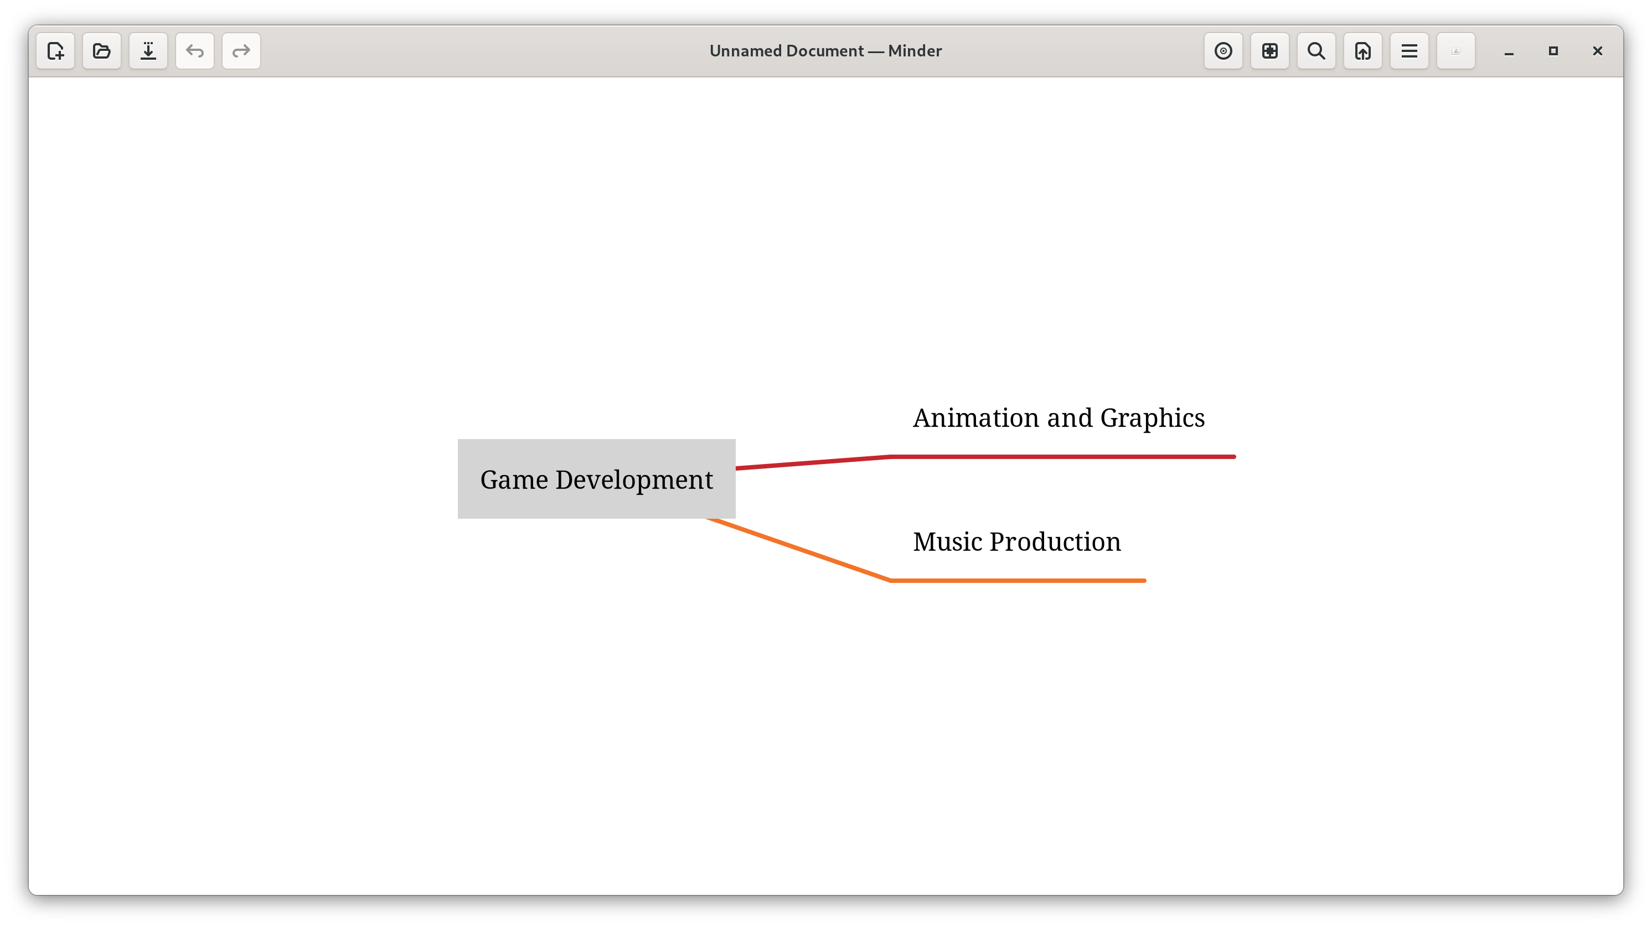
Step 8. Moreover, it is possible to add further elaboration to individual Child Notes by adding them a Child Note.
- Follow Step 6 but instead of clicking on the Root Node, click on the Child Note that you would like to add further information.
- We will add “Sound Recording” as a Child Note for “Music Production”.
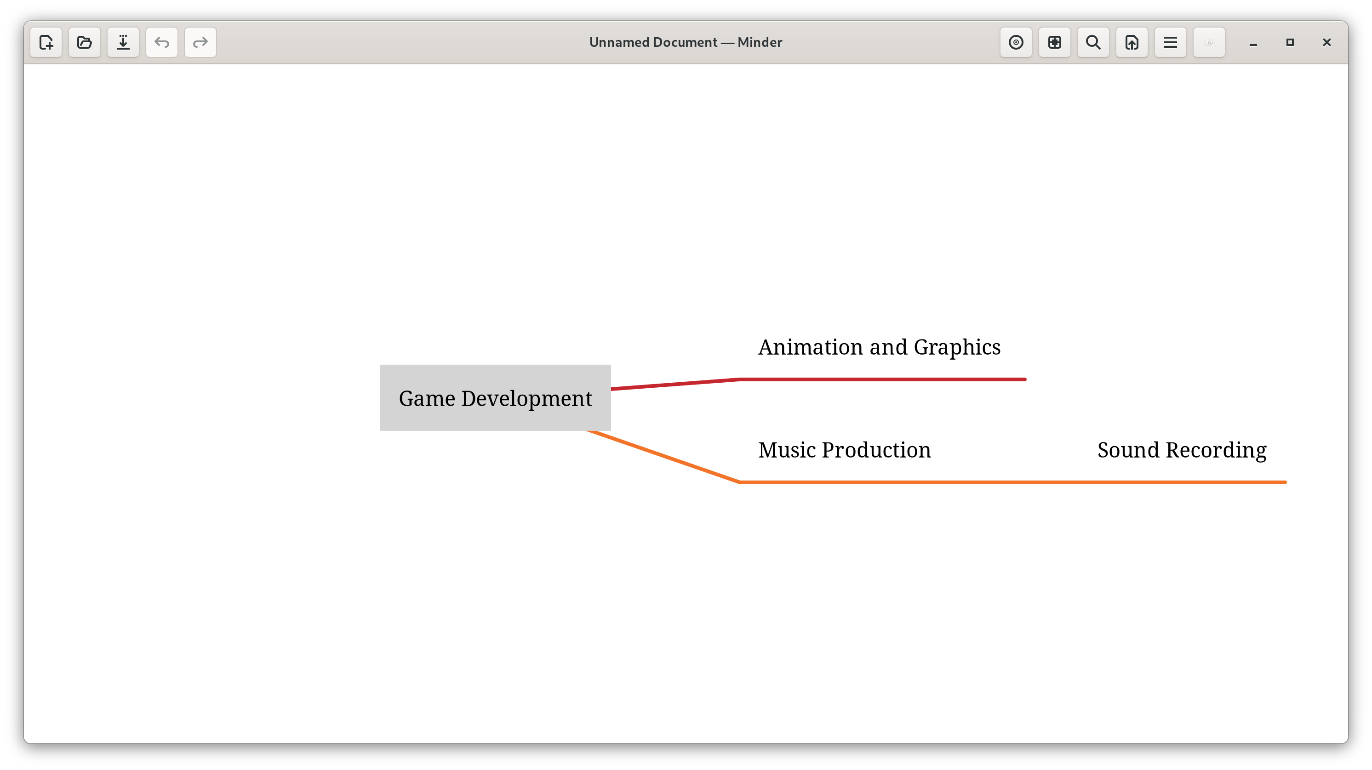
Step 9. However, we may encounter incorrect spelling mistakes or changes of thought while creating the Mind Map. In such a scenario, it is feasible for us to edit our Idea for each Note.
1st Option:
- Double Click on the Root/Child Note you want to Edit.
- Start Modifying your Idea.
—————————————————————————————————————
2nd Option:
- Left Click on the Root/Child Note you want to Edit.
- Press the “e” key on your keyboard.
- Make some changes.
By adopting Option 1, we modified “Sound Recording” to “Guitar Recording”.
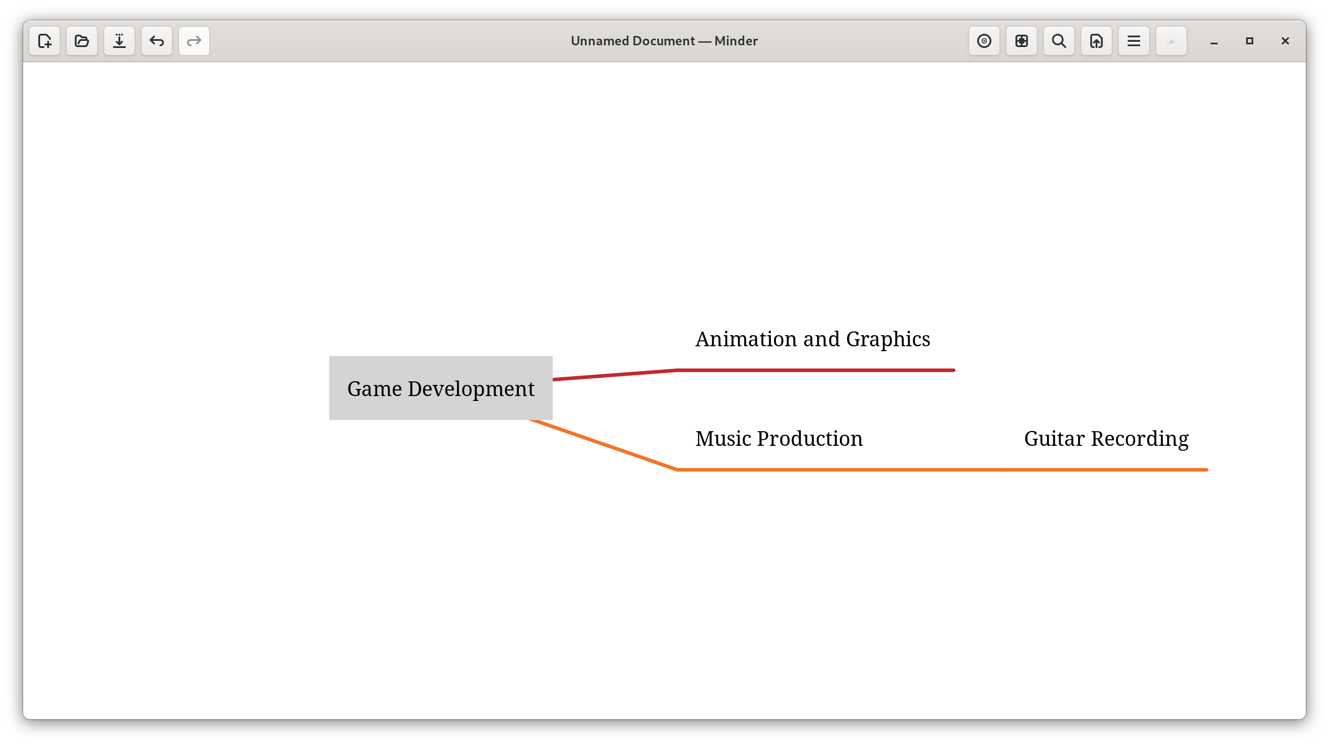
E.N.D

Draw.io
Draw.io is a free and open source cross-platform graph drawing software that could be utilized for Developing Mind map

Draw.io Installation Guide (Fedora Linux)
Here is the Simple Tutorial that helps you install Draw.io on Fedora Linux. Let’s start.

If there’s any concern regarding this guide, please refer to this link.
Step 1. First, on your Fedora, move your mouse to the top-left corner of your screen.
You should see the following screen:

Step 2. Left Click “Type to search”.

Step 3. Enter the word “Terminal”.

Step 4. After Left Clicking on the Terminal Icon. You should see the following terminal pop out.
Step 5. Enter the above command in the terminal:
sudo dnf install snapd
Then enter your user password into the terminal.
Make sure you have the same output as follows.
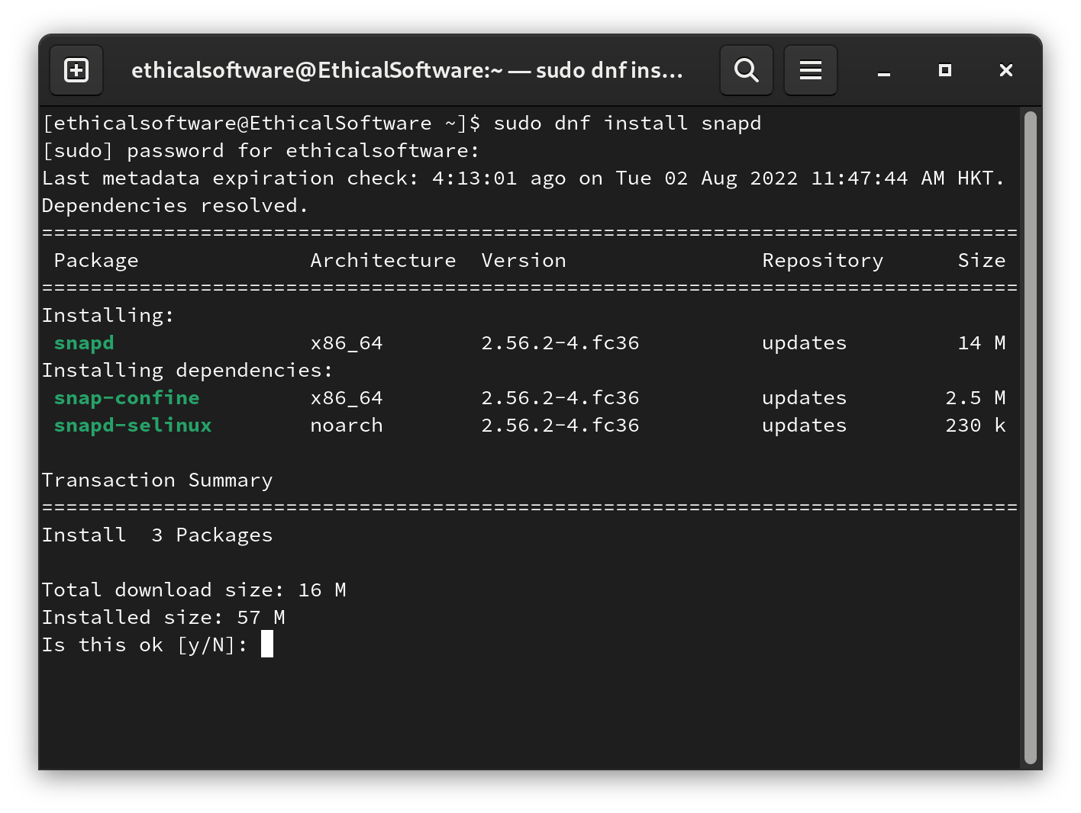
Step 6. Enter the letter: y, and you should see the following output.
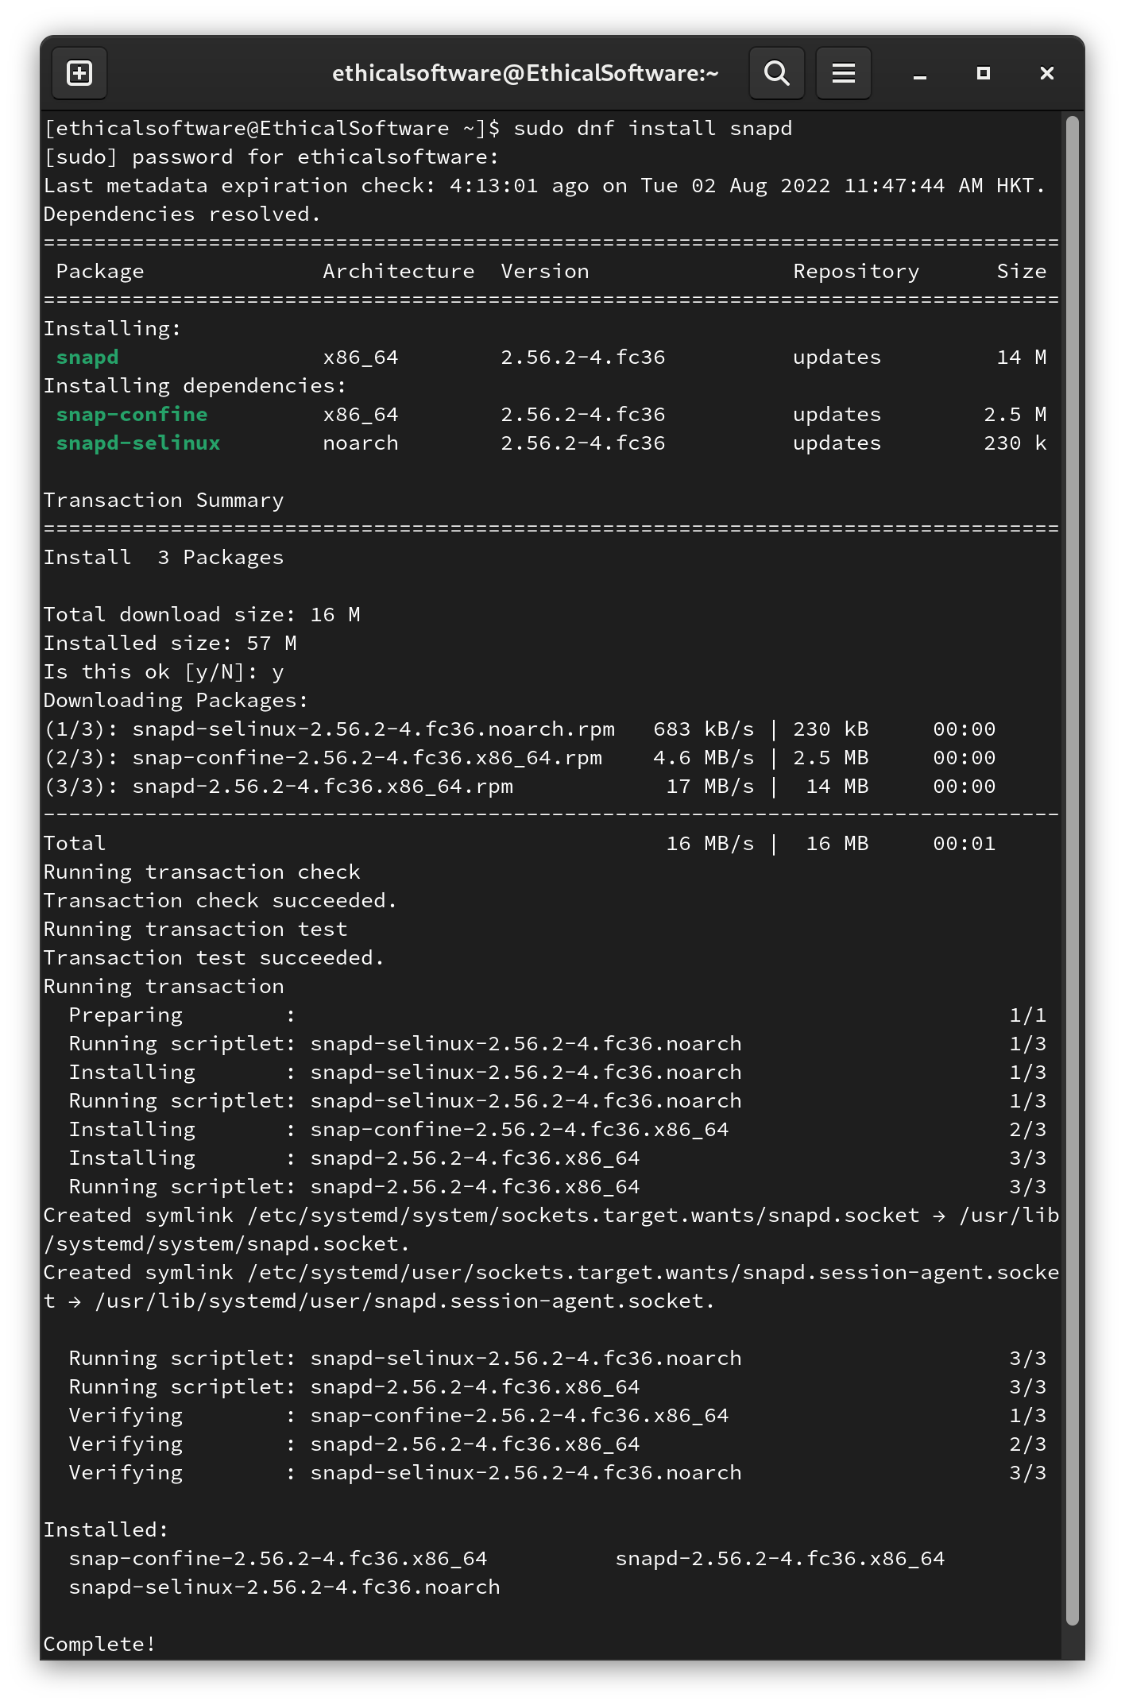

Step 7. Enter the above command in the terminal and press Enter key on the keyboard:
sudo ln -s /var/lib/snapd/snap /snap

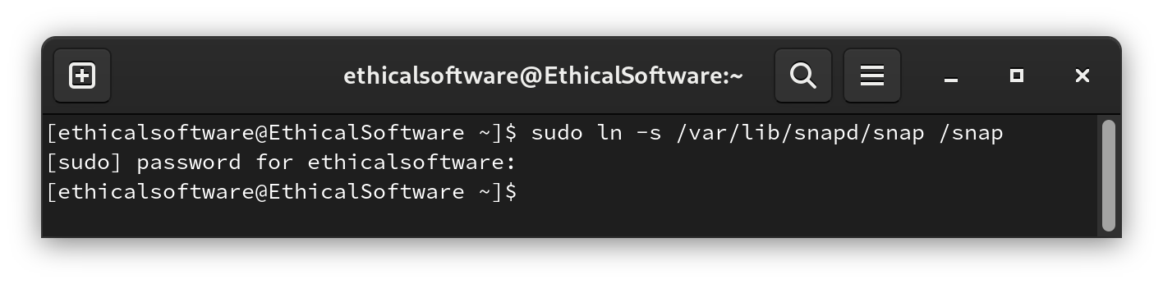

Step 8. Enter the above command in the terminal and press Enter key on the keyboard:
sudo snap install drawio
Wait for 1 - 2 minutes, and if there’s no error message from the terminal, you have successfully installed draw.io for mind map creation.

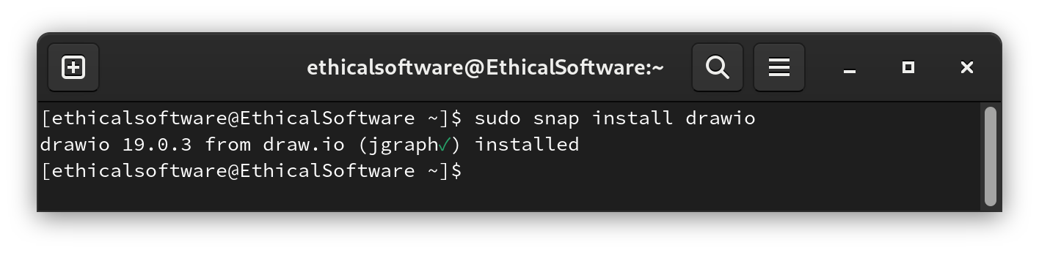

Step 9. In order to start the Draw.io application.
Enter the above command in the terminal and press Enter key on the keyboard:
drawio
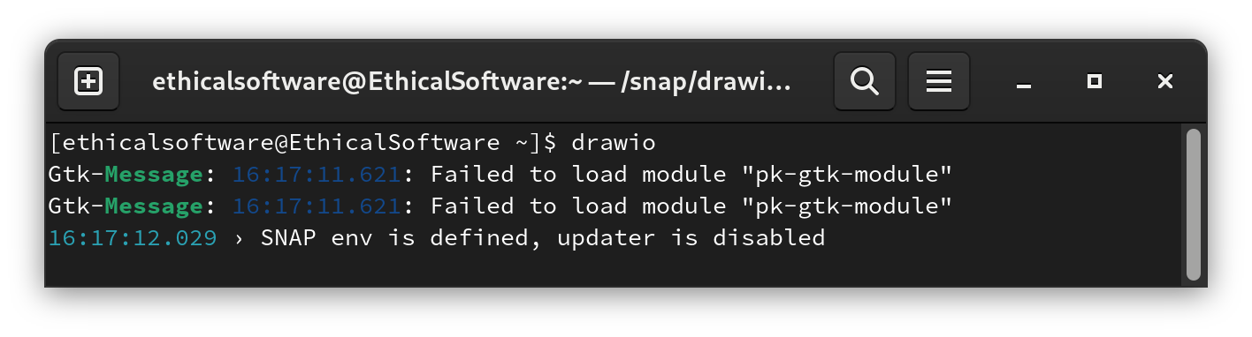
Have fun drawing with Draw.io!
E.N.D

https://snapcraft.io/install/drawio/fedora#install

